Mid-Project Progress Report: SmartClinic Database System

Member Name | Student ID | Designated Project Role | Total & ongoing contributions & works
Zinat Abuassi | 240064564 | Team Leader &  Implementation Lead (Task 2) | Initialized a GitHub repo and then created  the project report; Wrote out the Task 2 MySQL DDL scripts and the Task 2 MySQL DML scripts, and used these in the creation of the  database schema and constraints, and  arranged the workflow of the entire team
Razan Khalid Baattia | 240026080 | Database Architect (Task 1) | Performed requirement analysis, drew up EER model ideas, designed the entity relationship diagram & cardinalities, wrote design assumptions and generated mapping with the relational database model.
Nada Ali Alfahadi | 240027052 | SQL Operations Lead (Task 3) | Generated basic and advanced (multiple- join) sql for system  test. Created sql and/or stored procedures  containing sub queries. Used group by, avg, count, max etc  functions. Developed update/delete sql statements for testing.
Jana Banajah | 230015492 | Evaluation &  Documentation Lead (Task 4) | Task 4 lead in compilation of task in reflection, analysis of the trade-off.  Documenting steps in the problem-solving for an Artificial Intelligent  based process including  specifying disclosures  AI usage, to identify and check out for the quality of report.

We've begun planning, creating the software as well as performing the database design for SmartClinic. Our goal with SmartClinic will be to remove some of the manual processes required at a clinic and automate all the data entry and transaction processes. Below is what we have so far.
Task 1 (Database Design):
Fully modelled 6 superclasses and 1 subclass of the necessary clinic's entity/relation relationships: Patients, Staff, Doctor, Appointments, Payments, Treatment & Medicine. And established the relationship mapping for all entities (defined primary keys, foreign keys, cardinalities & developed relationships for clinic staff specialization using EER diagrams, which is the inheritance relationship between Staff and Doctor).
Next Step: The final EER diagram will be added according to the completed relational schema mapping.
Task 2 (Database Implementation):
The relations were developed using MySQL workbench and primary & foreign keys were established. Any additional restraints such as referential integrity & null constraints were added. The initial entity/key tables in the database were loaded with minimum of 5 data points.
GitHub Project Repository Setup: Initial repository setup https://github.com/S240064564/SmartClinic_Database_project.git was created. The repo allows for file management of database structure and the various queries. All database documents and work conducted so far have been added.
2. Key Technical decisions and architecture:
Entity relationship modelling- super-class / sub-class inheritance using EER's to represent clinic's Staff specialization (Super type - Staff, and Sub-type - Doctors). This eliminates redundancy and permits sub-types to store specific information in the medical professionals, and also permits relationships between (Treatments & Appointment) records to include cascade deletes.
Task 3: Advanced SQL operation implementation:
The required SQL operations have been completed in MySQL, including SELECT, JOIN, nested queries, aggregate functions with GROUP BY, and UPDATE/DELETE statements. All queries were implemented and tested successfully, and screenshots of both the SQL code and corresponding outputs were added.
Next Step:
The final SQL script will be fully completed for implementation in MySQL Workbench and will include a database VIEW and one database TRIGGER to automate the daily report of patient appointments and updates to the log after every transaction, respectively. Screenshots demonstrating the successful execution of both the VIEW and TRIGGER will also be included.

Task 4: Project Reflection

Design Decisions, Trade-offs, and Rationale
The design of the SmartClinic database centered on accurately modeling the clinic's real-world entities and relationships[span_6](start_span)[span_6](end_span). The most significant design decision was using an EER superclass/subclass relationship, with Staff as the supertype and Doctor as a subtype[span_7](start_span)[span_7](end_span). This avoided duplicating shared attributes while allowing role-specific data like specializations[span_8](start_span)[span_8](end_span). Furthermore, for medication tracking, we considered storing prescribed drugs directly as a single attribute in the Treatments table[span_9](start_span)[span_9](end_span). However, we chose a separate Medicine entity with a junction table (Treatment_Medicine)[span_10](start_span)[span_10](end_span). While this alternative introduced the trade-off of requiring multi-table JOINs, it ensured proper 3NF normalization and allowed tracking stock quantities accurately[span_11](start_span)[span_11](end_span).

Team Issues Encountered and Resolutions
During implementation, the team encountered two main technical issues[span_12](start_span)[span_12](end_span). First, foreign key creation errors occurred in MySQL Workbench because child tables were executed before parent tables existed[span_13](start_span)[span_13](end_span). We resolved this by reordering the DDL script so that parent tables (Staff, Patients) were created before dependent entities (Doctors, Appointments)[span_14](start_span)[span_14](end_span). Second, a logical FK error arose because doctor_id in Appointments initially referenced the general Staff table instead of the Doctor sub-entity[span_15](start_span)[span_15](end_span). We fixed this by updating the foreign key constraint to reference Doctors directly, ensuring only valid doctors can be assigned to appointments[span_16](start_span)[span_16](end_span).

Utilization of AI Tools
AI tools (such as ChatGPT) were used in a supporting, non-authoring role during the project[span_17](start_span)[span_17](end_span). They assisted in diagnosing MySQL error messages regarding foreign key creation order and reviewing the structure of report drafts[span_18](start_span)[span_18](end_span). The team manually verified, modified, and tested every AI-suggested code fix within MySQL Workbench before applying it to the database, ensuring complete understanding and accuracy[span_19](start_span)[span_19](end_span).

Suggested Future Technical Enhancements
If given more time and resources, the schema could be extended with stored procedures for common operations like booking appointments to enforce business logic[span_20](start_span)[span_20](end_span). Adding indexes on frequently queried foreign keys (such as patient_id and doctor_id) would optimize query performance as data grows[span_21](start_span)[span_21](end_span). Additionally, introducing role-based access control (RBAC) at the database level would strengthen security by restricting sensitive patient and payment records to authorized staff only[span_22](start_span)[span_22](end_span).

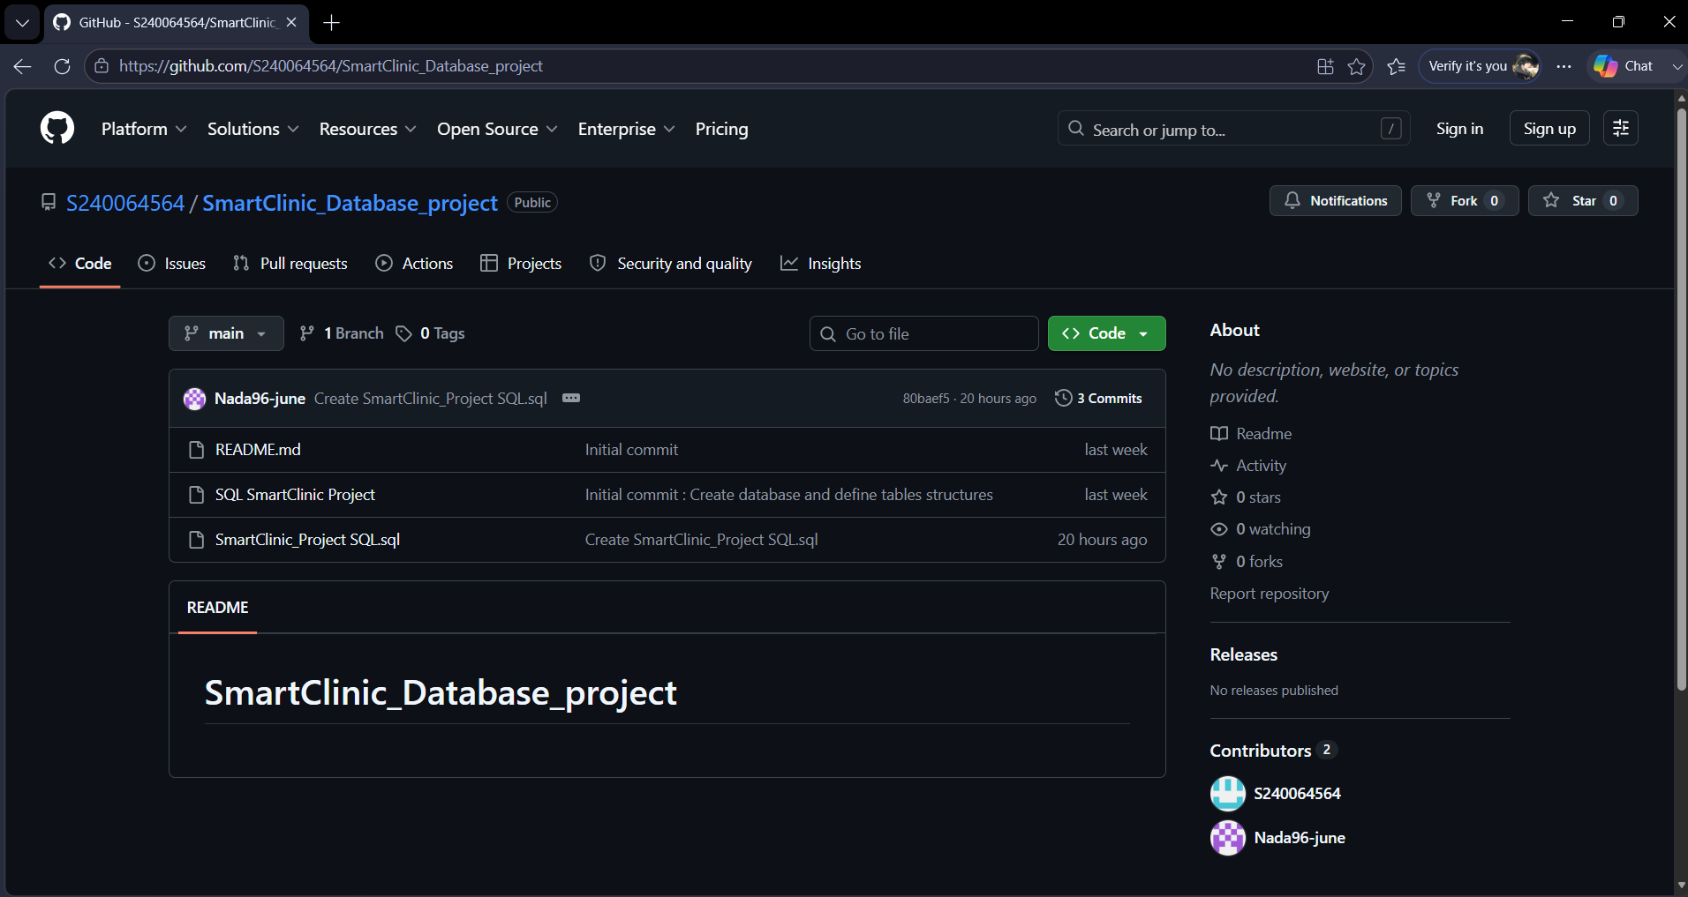
Figure 1: SmartClinic GitHub repository overview with project files, and history of team contribution

